**[](https://www.istockphoto.com/photo/red-deer-isolated-on-white-gm182460415-11976348)StAG’s Newsletter**

**November/ December 2024**

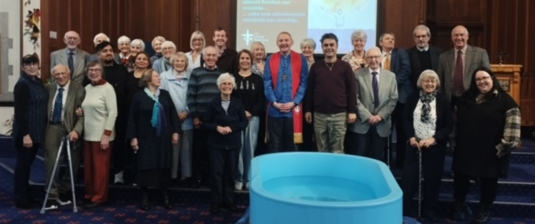

“Praise with me the One who delights to give us all that we need, who holds close the downtrodden, those at the margins; who is the edge and the centre of being.” Psalm 146

***Family news***

I am very sorry to pass on the news that Patricia Turner has died recently, having lived in Beechville for a few years. Pat had been a member of our church most of her life, and a dedicated member of Thursday Circle. Her funeral is at Overdale on Friday, 22 November.

On Monday this week, we had more sad news – that Enid Ashton died in a Hospice near where she lived in Malton, N Yorkshire. She had been there for a few months and died peacefully with both Judith and Hilary with her. Her funeral is on Wednesday, 20th November in York. Please ask if anyone wants further details. Our prayers and thoughts are with both Pat and Enid’s families.

We have helped both Laura Baron and John Swarsbrick to celebrate their 90th birthdays recently and are getting used to glorious cakes after Sunday service! Congratulations, both!

And then, what I personally think is the best piece of news (and I’m sure you will all agree) we were able to welcome Vicky and Arman Eminem into our membership, following their baptism at our Sunday service - a most precious and memorable occasion!

We have been sorry to say goodbye to Jan and Ian McNab recently and send our very sincere wishes for a happy future as they move to Garstang. We will miss you both!

***Booked preachers***

3-11 joint service at Victoria Hall

10-11 Rev Walt Johnson

17-11 Rev Rob Hoch

24-11 Mrs Gill Dascombe

1-12 Rev Mark Cowling

8-12 Rev Tony Burnham

22-12 Rev Walt Johnson

***Diary dates***

Tuesday, 26 November = Advent Bible Study , 7.30pm.at Bank Top URC

Sunday, 3rd November – joint service at Victoria Hall, 10.30. Gifts for the Destitution Project may be brought with you. All offerings this month will go to DP and in December they will be taken to Lucie’s Pantry (Emmaus)

Sunday, 8th December - Gift and Toy Service - please bring unwrapped gifts for children and teenagers.

Tuesday, 10th December - Advent Bible Study at Bank Top URC at 7.30pm.

***CHRISTMAS POST BOX***It’s that time of year again, and how quickly it comes around.  
The Christmas post box will be put out in church on Sunday 24th  
November, 1st and 8th December for you to post your cards. The cards  
will then be distributed at the end of church services on Sundays 15th  
and 22nd December. If you prefer there will be a board up for you to put   
up one 1 single card for everyone.  
Please ensure the cards are only for the church congregation and that  
the recipient’s full name and address is on the envelope.  
Any voluntary contributions in respect of the 'Postage' will be  
gratefully received.

And finally, all that is left to say is

HAPPY CHRISTMAS, EVERYBODY!