**[](https://www.istockphoto.com/photo/red-deer-isolated-on-white-gm182460415-11976348)**

**StAG’s NEWSLETTER**

**May – June 2025**

Dear All,

Apologies for the lateness of this newsletter, but April went past too quickly for me!! We have had several events at church recently, not least a woderfully uplifting Easter celebration – Happy Easter!

We send our most loving congratulations to Ali and Parvine on the arrival of baby Adam! And best wishes to Adam and Diana on their baptisms, another ‘first’ for the Easter service! Welcome, both, to St Andrew and St Gearge’s URC!

And then there was the holiday to Thornleigh Hotel at Grange, where, thanks to Jim and Elizabeth, we had a most restful and yet challenging time! They had even booked the weather for us! Thank you!

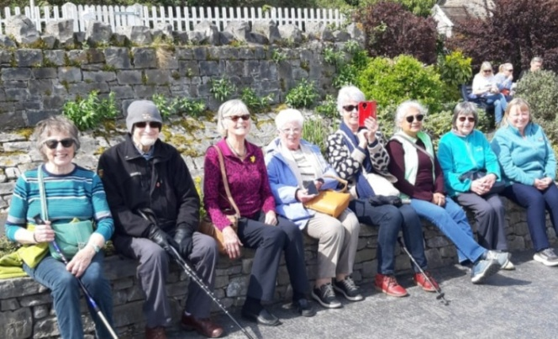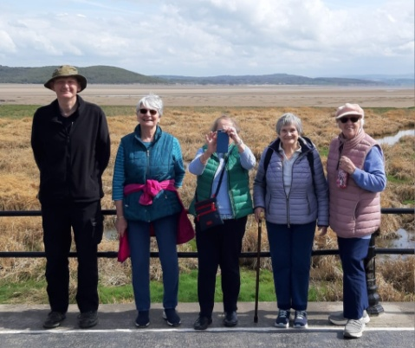(Thank you, Ali !)

**Preachers for May/June**

4-5 Worship Group

11-5 Rev Tony Burnham

18-5* Rev Walt Johnson

25-5 Mr Peter Holland

1-6 Mrs Gill Dascombe

8-6 Rev Mark Cowling, [ Zoom, for Pentecost]

15-6* Rev Walt Johnson

22-6 T.B.A

29-6 Mrs Linda Gillett

6-7 Rev Walt Johnson

Several people belonging to our family have been having medical problems recently. I don’t want to name names but you all know who you are and that you are in our prayers!

**SHALOM**